# Case Study #2 - Pizza Runner

# SCHEMA

# TABLES

# 

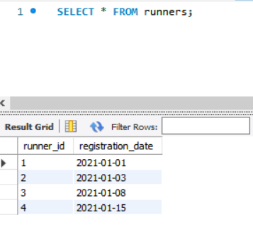

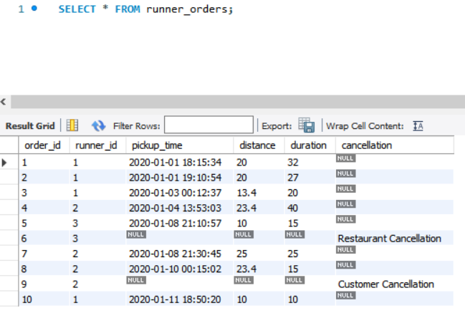

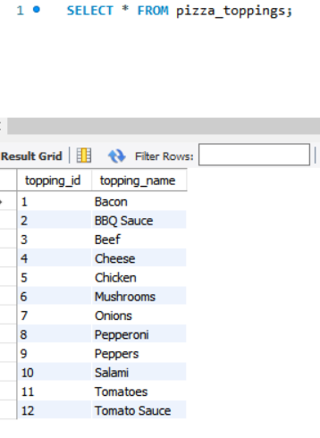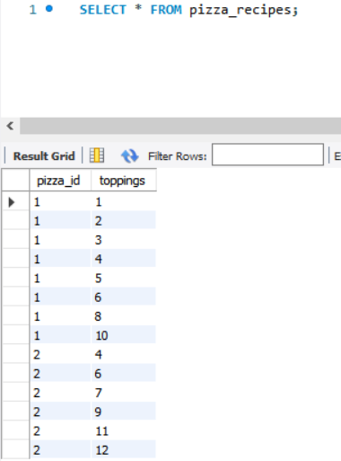

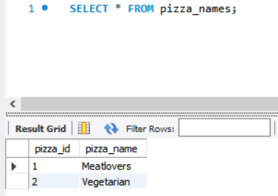

**Answer to Questions:**

**Pizza Metrics Analysis:**

Q1. How many pizzas were ordered?

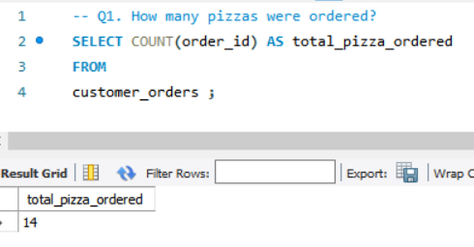

Q2. How many unique customer orders were made?

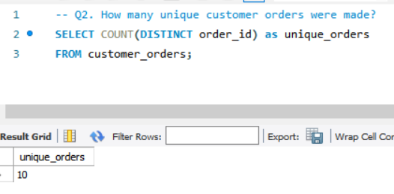

Q3. How many successful orders were delivered by each runner?

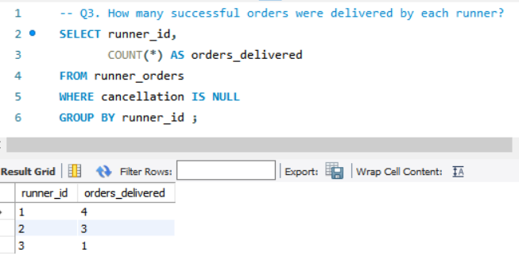

Q4. How many of each type of pizza was delivered?

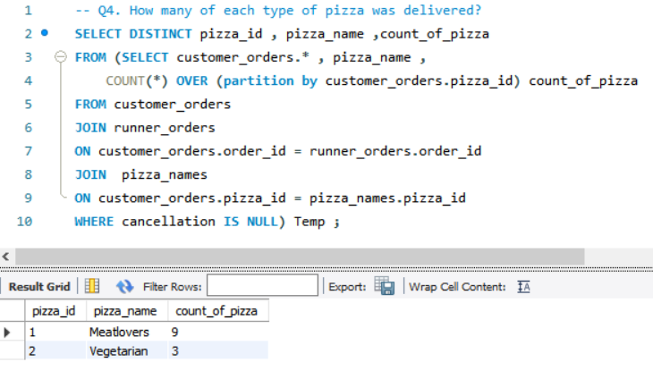

Q5. How many Vegetarian and Meat lovers were ordered by each customer?

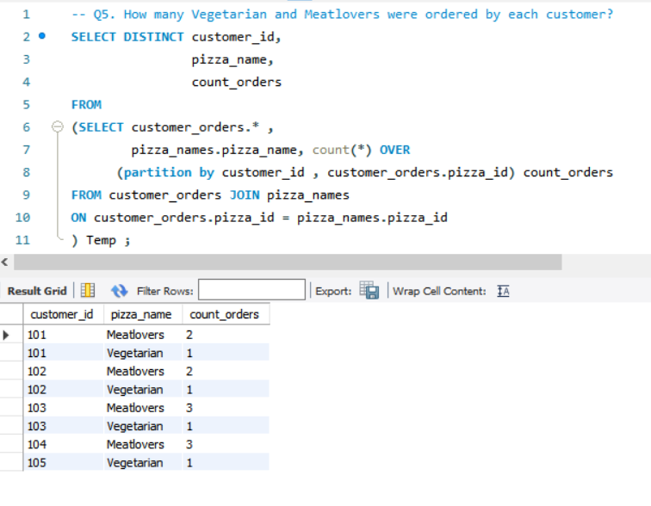

Q6 What was the maximum number of pizzas delivered in a single order?

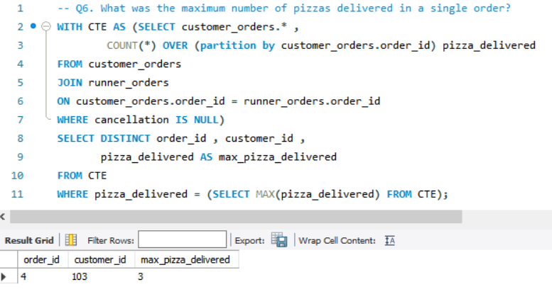

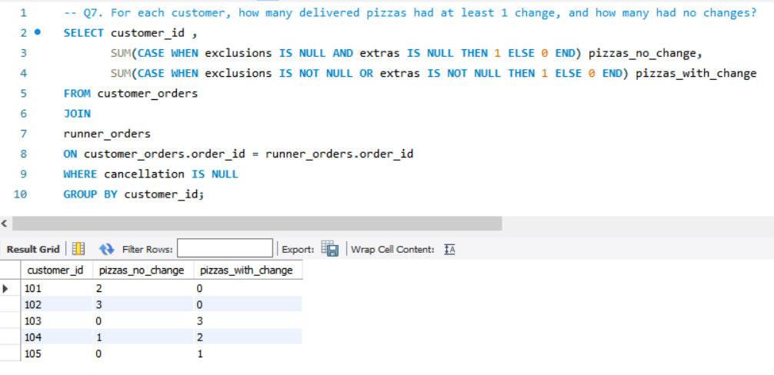Q7. For each customer, how many delivered pizzas had at least 1 change, and how many had no changes?

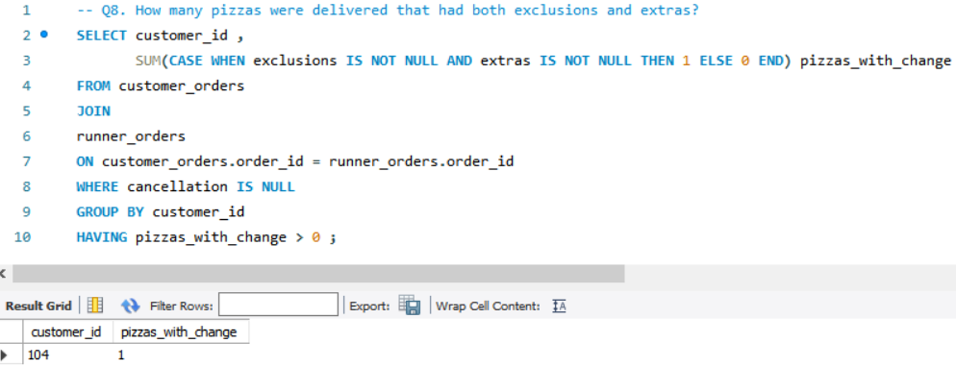Q8 How many pizzas were delivered that had both exclusions and extras?

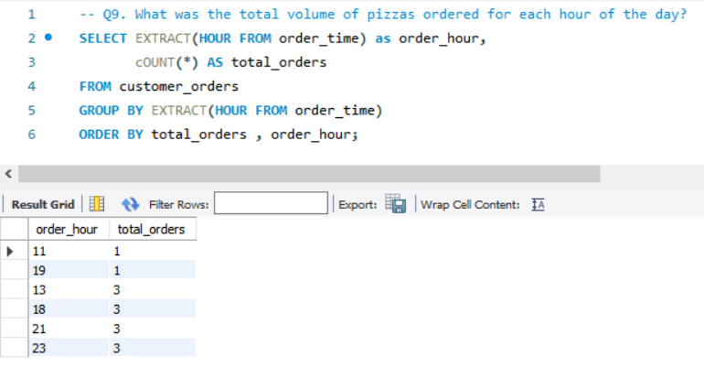Q9. What was the total volume of pizzas ordered for each hour of the day?

Q10. What was the volume of orders for each day of the week?

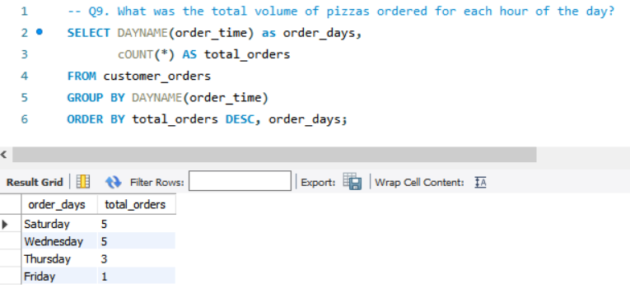

# Runner and Customer Experience:

# Q1. How many runners signed up for each 1week period? (i.e. week starts 2021-01-01)

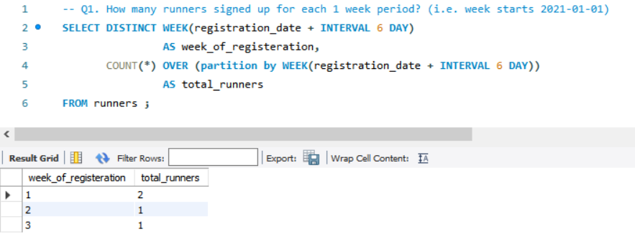

**EXPLANATION:**

* Since the week started from ‘01-01-2021’, for first week we observed 2 registrations on ‘01-01-2021’ and ‘03-01-2021’, for second week there was 1 registration on ‘08-01-2021’ and finally for third week there was 1 registration on ‘15-01-2021’

Q2. What was the average time in minutes it took for each runner to arrive at the Pizza Runner HQ to pick up the order?

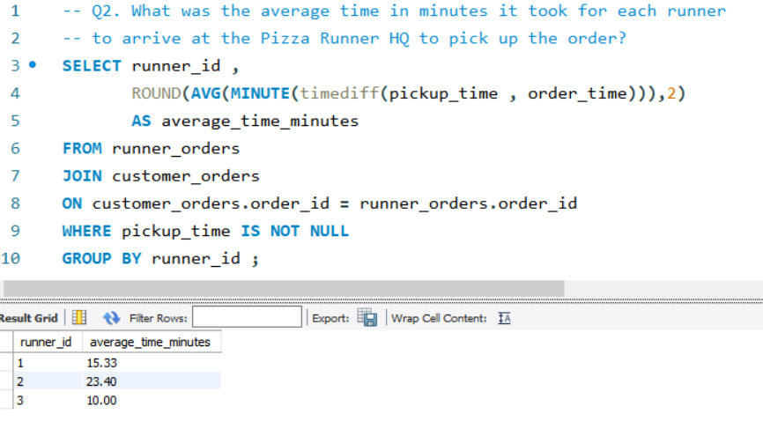

Runner 1 took on average 15 minutes

Runner 2 took on average 23 minutes

Runner 3 took around 10 minutes on average (least time) to arrive at Pizza Runner HQ to pick up the order .

### Q3. Is there any relationship between the number of pizzas and how long the order takes to prepare?

**RELATIONSHIP**

**->** More the quantity of pizza ordered, more will be the preparation time. Orders with a single pizza can be prepared with an average time of 12 minutes while orders having 3 pizzas take about around half an hour for preparation.

### Q4. What was the average distance travelled for each customer?

### 

### Q5. What was the difference between the longest and shortest delivery times for all orders?

### Q6. What was the average speed for each runner for each delivery and do you notice any trend for these values?

**TREND:** For runner id 3 having least average speed, we observe least deliveries. Comparatively runner id 1 and 2 completed more deliveries because they have higher average speed

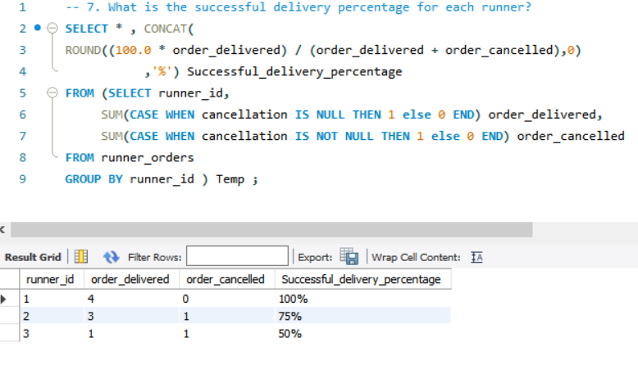7. What is the successful delivery percentage for each runner?

### **C. Ingredient Optimisation**

Q1. What are the standard ingredients for each pizza?

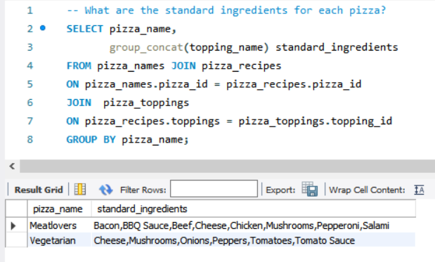

### Q2. What was the most commonly added extra?

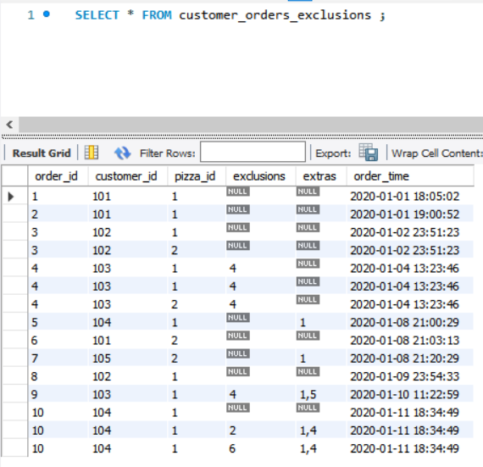 To solve this, I first normalized customer orders table.

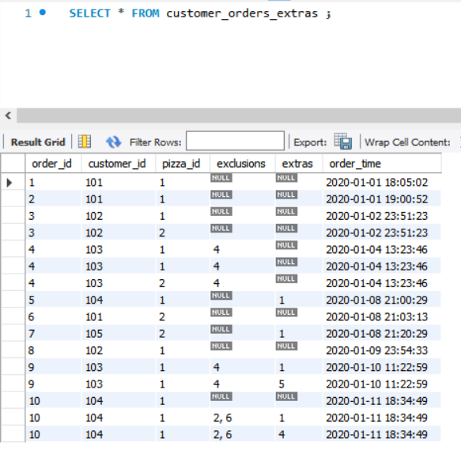

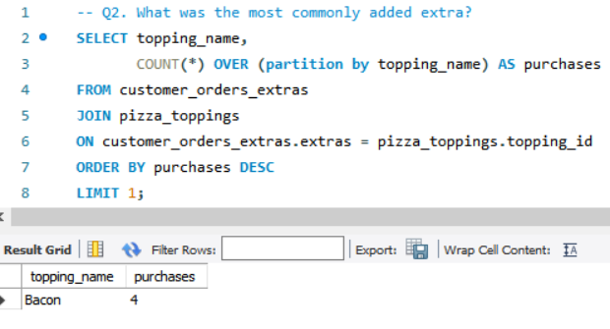

### Q3. What was the most common exclusion?

### 4. Generate an order item for each record in the customer orders table in the format of one of the following: Meat Lovers , Meat Lovers - Exclude Beef , Meat Lovers - Extra Bacon

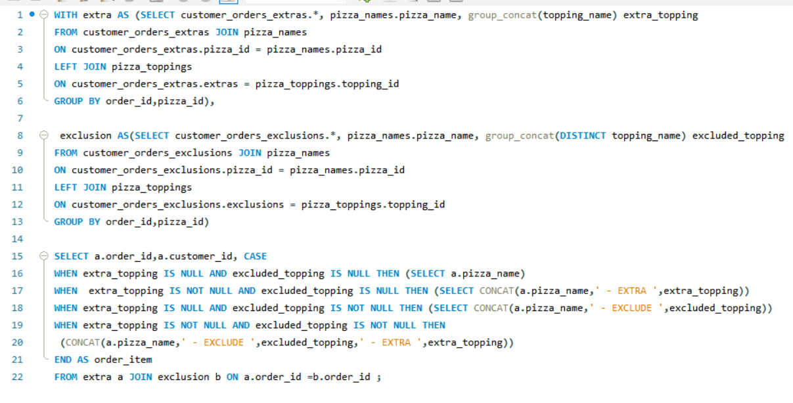

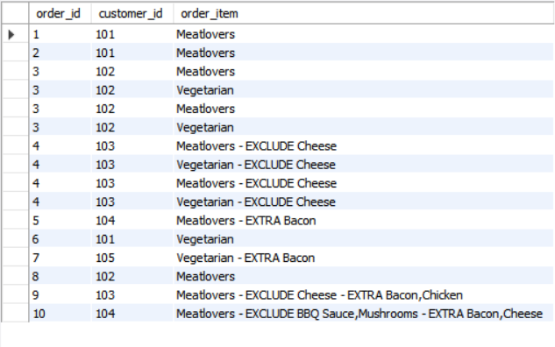

### Q5. Generate an alphabetically ordered comma separated ingredient list for each pizza order from the customer orders table and add a 2x in front of any relevant ingredients

**Here the output is like->**

pizza name: extras (if any) 2X relevant ingredients (excluding exclusions if any)

### Q6. What is the total quantity of each ingredient used in all delivered pizzas sorted by most frequent first?

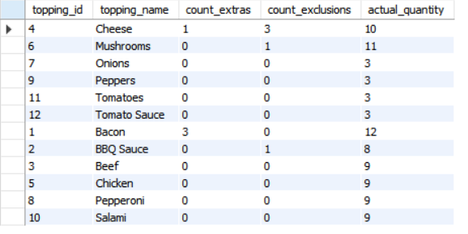

Total quantity of each ingredient used is calculated as:

(Total no. of times that ingredient was a standard ingredient for all sold pizzas + no. of times it was added as an extra ingredient in all sold pizzas) – no. of times it was excluded from standard ingredients for all sold pizzas.

### **D. Pricing and Ratings**

Q1. If a Meat Lovers pizza costs $12 and Vegetarian costs $10 and there were no charges for changes - how much money has Pizza Runner made so far if there are no delivery fees

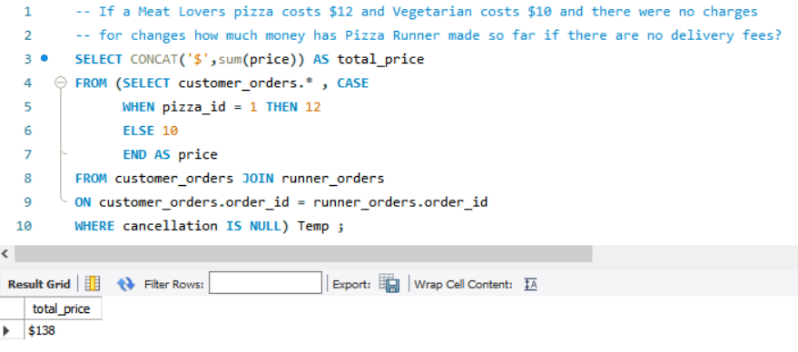

### Q2. What if there was an additional $1 charge for any pizza extras?

Like Q1 calculated the base prize for pizza through temporary table pizza price. Next created another temp table COUNT_EXTRAS to count the extras ordered for successful deliveries and added that to the base price because each extra cost $1.

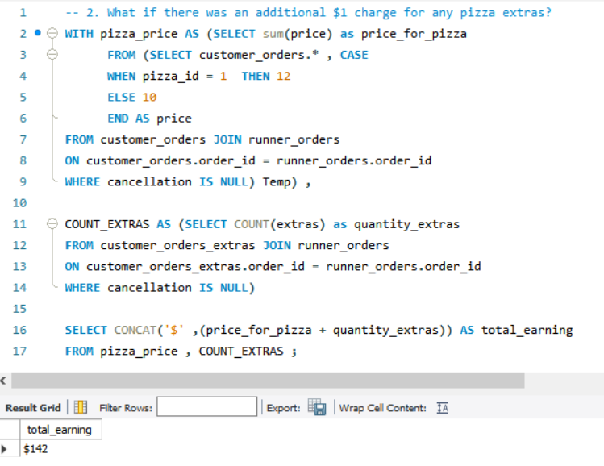

Q3. The Pizza Runner team now wants to add an additional ratings system that allows customers to rate their runner, how would you design an additional table for this new dataset - generate a schema for this new table and insert your own data for ratings for each successful customer order between 1 to 5.

NOTE: While generating this table, order id 6 and 9 can’t be included because these orders were cancelled so there can be no runner rating for it.

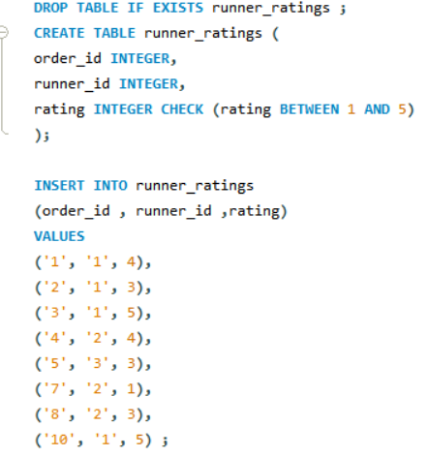

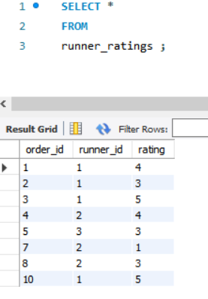

Q4. Using your newly generated table - can you join all of the information together to form a table which has the following information for successful deliveries?

* + Customer id
  + Order id
  + Runner id
  + rating
  + order time
  + pickup time
  + Time between order and pickup
  + Delivery duration
  + Average speed
  + Total number of pizzas

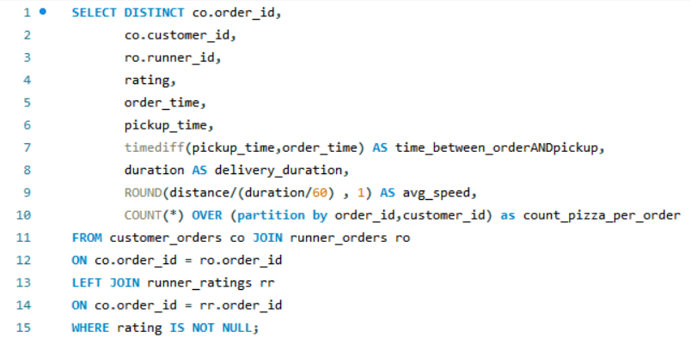

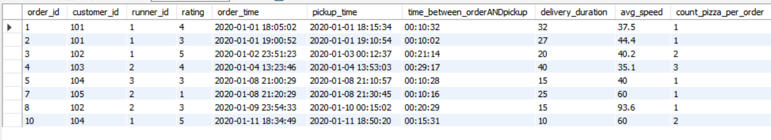

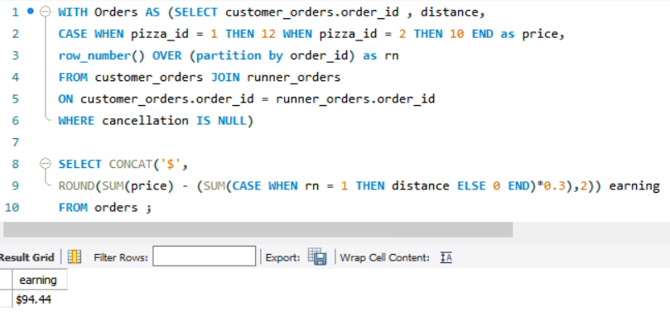Q5. If a Meat Lovers pizza was $12 and Vegetarian $10 fixed prices with no cost for extras and each runner is paid $0.30 per kilometre travelled, how much money does Pizza Runner have left over after these deliveries?

### **E. Bonus Questions**

Q1. If Danny wants to expand his range of pizzas - how would this impact the existing data design? Write an INSERT statement to demonstrate what would happen if a new Supreme pizza with all the toppings was added to the Pizza Runner menu?

* If Supreme pizza is to be added in the database, we need to use Insert statement for table pizza names and pizza recipes both. And after inserting the values, this is how the two tables looks like:

